Municipal Educational Establishment
Secondary School №1
Pavlovo Nizhegorodskaya Oblast

Halloween

Carried out by a pupil:
Oparysheva Angelika, 11 form “A” (17 years old)
Scientific adviser:
Molodtsova.E.S

Pavlovo
2013
Contents
- Introduction
- The origin of Halloween
- Halloween in Great Britain and other countries
  - Symbols
  - Trick-or-treating and guising
  - Costumes
  - Games and other activities
  - Foods
- Halloween in Russia: for and against

INTRODUCTION

Globalization has made world a smaller place. Its impact is not limited to the economy of the countries only, the term globalization actually refers to every aspect of life: social, political, psychological, linguistic and of course, cultural. bnbnaaIt goes without saying that it is very interesting and important to learn about the traditions of other countries and people. As we learn the language of the other country, we are sure to learn about its culture, people’s character, their outlooks, likes and dislikes. It happens so that learning the language, we also try to imply on ourselves some ideas, traditions, fashion, and even the way of life. We imitate western way of life, sometimes forgetting about our own cultural identity.
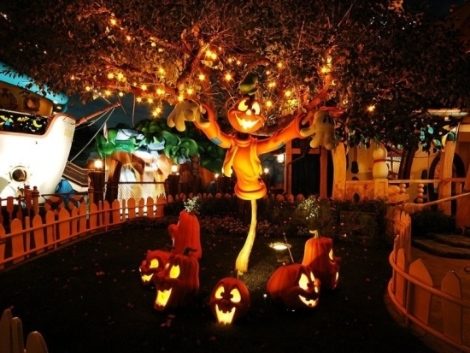
Young people, students at schools and universities are fond of celebrating such holidays as St Valentine’s Day, St Patrick’s Day, Halloween. These holidays came from the USA and Europe, and are quite new and attractive for us. But do all Russians approve of celebrating these holidays? In our research work we would like to take into consideration one of these holidays, which is becoming more and more popular among young people – Halloween.
The aim of my research:
To find out if it is right to celebrate Halloween in Russia. I would also like to understand the attitude of Russian people of different groups towards this holiday.
The objectives:
- to learn about the origins of this holiday, the way it has been observed throughout the history;
- to point out and analyze the reasons of its popularity in Russia;
- to make a survey about the attitude of Russian people of different groups towards Halloween;
- to analyze the information and arrange it in the form of a diagram;
- to analyze and compare the results of the survey;
The methods of my research:
- Interviewing
- Analysis
- Comparing
- Studying literature on the topic

The origin of Halloween
On October 31st, the eve of All Saints Day or just Halloween is celebrated.
The tradition of Halloween began in the fifth century B.C. by the Irish Celts, who organized their year according to the agricultural calendar and marked the transition from one year to the next on October 31.
The Celts, ancient inhabitants of Great Britain, celebrated their New Year on November 1st. It was celebrated every year with a festival that marked the end of the «season of the sun» and the beginning of «the season of darkness and cold.
On the eve before their new year, October 31, it was believed that Samhain, who was the Lord of the Death and Prince of Darkness, called together all the dead people. The Celts believed the boundary between the worlds of the living and the dead became blurred on this night.
On October 31st, the Druids, who were the priests and teachers of the Celts, would meet in the hilltop in the dark oak forest. They considered oak trees to be sacred. The Druids would light fires and offer sacrifices of crops, animals and possibly even human beings. They told fortunes about the coming year by examining the remains of the animals that had been sacrificed.
When the morning arrived, the Druids would give an ember from their fires to each family who would then take them home to start new cooking fires at home. These fires would keep the homes warm and free from evil spirits.
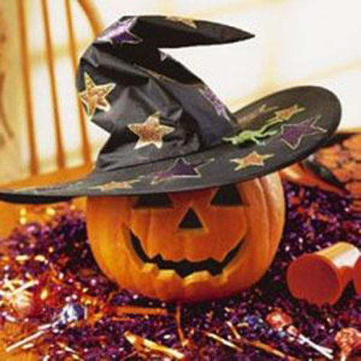
The story tells us that during the transition, spirits return to earth, looking for living bodies to possess for the following year. The Celts dress up in ghoulish costumes and parade around to frighten them away.
In the year 835 AD the Roman Catholic Church made November 1st a church holiday to honour all the saints. This day is called All Saint's Day. It used to be also known as Hallowmas. Gradually, over the years, October 31st became known as All Hallow Even, eventually All Hallow's Eve, and then Halloween as we know it today.
It was thought that even strangers could help a soul's passage to heaven by saying prayers.

Halloween in Great Britain and other countries
In Britain, these customs came under attack during the Reformation as Protestants berated purgatory as a "popish" doctrine incompatible with the notion of predestination. The rising popularity of Guy Fawkes Night (5 November) from 1605 onward, saw many Halloween traditions appropriated by that holiday instead, and Halloween's popularity waned in Britain, with the noteworthy exception of Scotland. There and in Ireland, the rebellious Guy Fawkes was not viewed with the same criminality as in England, and they had been celebrating Samhain and Halloween since at least the early Middle Ages, and the Scottish kirk took a more pragmatic approach to Halloween, seeing it as important to the life cycle and rites of passage of communities and thus ensuring its survival in the country.
North American almanacs of the late 18th and early 19th century give no indication that Halloween was celebrated there.[ The Puritans of New England, for example, maintained strong opposition to Halloween[ and it was not until the mass Irish and Scottish immigration during the 19th century that it was brought to North America in earnest. Confined to the immigrant communities during the mid-19th century, it was gradually assimilated into mainstream society and by the first decade of the 20th century it was being celebrated coast to coast by people of all social, racial and religious backgrounds.

Symbols and traditions of Halloween
Symbols
Development of artifacts and symbols associated with Halloween formed over time. The turnip has traditionally been used in Ireland and Scotland at Halloween, but immigrants to North America used the native pumpkin, which is both much softer and much larger – making it easier to carve than a turnip. The American tradition of carving pumpkins is recorded in 1837 and was originally associated with harvest time in general, not becoming specifically associated with Halloween until the mid-to-late 19th century.
The modern imagery of Halloween comes from many sources, including national customs, works of Gothic and horror literature (such as the novels Frankenstein and Dracula) and classic horror films (such as Frankenstein and The Mummy). Elements of the autumn season, such as pumpkins, corn husks and scarecrows, are also prevalent. Homes are often decorated with these types of symbols around Halloween.
Halloween imagery includes themes of death, evil, the occult, and mythical monsters. Black, orange, and sometimes purple are Halloween's traditional colors.

Trick-or-treating and guising
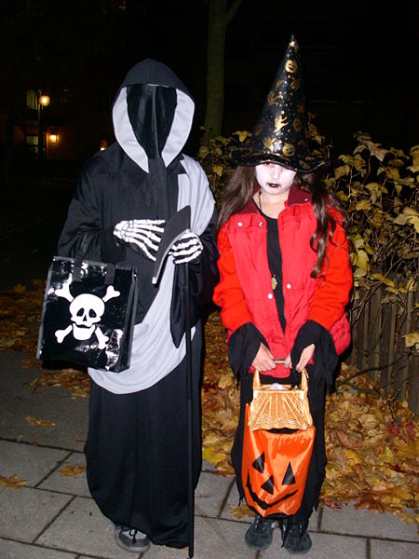
Trick-or-treating is a customary celebration for children on Halloween. Children go in costume from house to house, asking for treats such as candy (sweets) or sometimes money, with the question, "Trick or treat?" The word "trick" refers to a (mostly idle) "threat" to perform mischief on the homeowners or their property if no treat is given.
In Scotland and Ireland, guising – children disguised in costume going from door to door for food or coins – is a traditional Halloween custom, and is recorded in Scotland at Halloween in 1895 where masqueraders in disguise carrying lanterns made out of scooped out turnips, visit homes to be rewarded with cakes, fruit and money. The practice of Guising at Halloween in North America is first recorded in 1911, where a newspaper in Kingston, Ontario reported children going "guising" around the neighborhood.
American historian and author Ruth Edna Kelley of Massachusetts wrote the first book length history of Halloween in the US; The Book of Hallowe'en (1919), and references souling in the chapter "Hallowe'en in America":
“The taste in Hallowe'en festivities now is to study old traditions, and hold a Scotch party, using Burn's poem Hallowe'en as a guide; or to go a-souling as the English used. In short, no custom that was once honored at Hallowe'en is out of fashion now.”
In her book, Kelley touches on customs that arrived from across the Atlantic; "Americans have fostered them, and are making this an occasion something like what it must have been in its best days overseas. All Halloween customs in the United States are borrowed directly or adapted
The thousands of Halloween postcards produced between the turn of the 20th century and the 1920s commonly show children but not trick-or-treating. The editor of a collection of over 3,000 vintage Halloween postcards writes, "There are cards which mention the custom [of trick-or-treating] or show children in costumes at the doors, but as far as we can tell they were printed later than the 1920s and more than likely even the 1930s. Tricksters of various sorts are shown on the early postcards, but not the means of appeasing them". Trick-or-treating does not seem to have become a widespread practice until the 1930s, with the first U.S. appearances of the term in 1934, and the first use in a national publication occurring in 1939.

Costumes
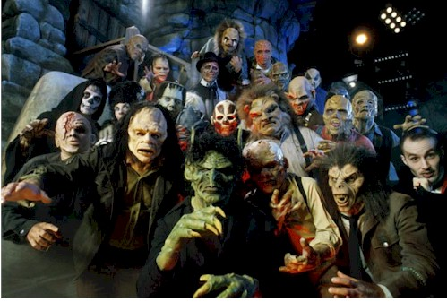
Halloween costumes are traditionally modeled after supernatural figures such as monsters, ghosts, skeletons, witches, and devils. Over time, in the United States the costume selection extended to include popular characters from fiction, celebrities, and generic archetypes such as ninjas and princesses.
Dressing up in costumes and going "guising" was prevalent in Ireland and Scotland at Halloween by the late 19th century. Costuming became popular for Halloween parties in the US in the early 20th century, as often for adults as for children. The first mass-produced Halloween costumes appeared in stores in the 1930s when trick-or-treating was becoming popular in the United States.
Halloween costume parties generally fall on or around October 31, often on the Friday or Saturday before Halloween.

Games and other activities
There are several games traditionally associated with Halloween parties. One common game is dunking or apple bobbing, which may be called "dooking" in Scotland in which apples float in a tub or a large basin of water and the participants must use their teeth to remove an apple from the basin. The practice is thought by some to have derived from the Roman practices in celebration of Pomona. A variant of dunking involves kneeling on a chair, holding a fork between the teeth and trying to drop the fork into an apple. Another common game involves hanging up treacle or syrup-coated scones by strings; these must be eaten without using hands while they remain attached to the string, an activity that inevitably leads to a very sticky face.
Some games traditionally played at Halloween are forms of divination. A traditional Scottish form of divining one's future spouse is to carve an apple in one long strip, then toss the peel over one's shoulder. The peel is believed to land in the shape of the first letter of the future spouse's name. Unmarried women were told that if they sat in a darkened room and gazed into a mirror on Halloween night, the face of their future husband would appear in the mirror. However, if they were destined to die before marriage, a skull would appear. The custom was widespread enough to be commemorated on greeting cards from the late 19th century and early 20th century.
Another game/superstition that was enjoyed in the early 1900s involved walnut shells. People would write fortunes in milk on white paper. After drying, the paper was folded and placed in walnut shells. When the shell was warmed, milk would turn brown therefore the writing would appear on what looked like blank paper. Folks would also play fortune teller. In order to play this game, symbols were cut out of paper and placed on a platter. Someone would enter a dark room and was ordered to put her hand on a piece of ice then lay it on a platter. Her "fortune" would stick to the hand. Paper symbols included: dollar sign-wealth, button-bachelorhood, thimble-spinsterhood, clothespin- poverty, rice-wedding, umbrella- journey, caldron-trouble, 4-leaf clover- good luck, penny-fortune, ring-early marriage, and key-fame.
The telling of ghost stories and viewing of horror films are common fixtures of Halloween parties. Episodes of television series and Halloween-themed specials (with the specials usually aimed at children) are commonly aired on or before Halloween, while new horror films are often released theatrically before Halloween to take advantage of the atmosphere.

Foods
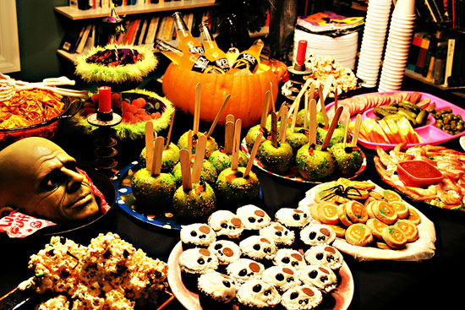
Because Halloween comes in the wake of the yearly apple harvest, candy apples (known as toffee apples outside North America), caramel or taffy apples are common Halloween treats made by rolling whole apples in a sticky sugar syrup, sometimes followed by rolling them in nuts.
One custom that persists in modern-day Ireland is the baking (or more often nowadays, the purchase) of a barmbrack, which is a light fruitcake, into which a plain ring, a coin and other charms are placed before baking. It is said that those who get a ring will find their true love in the ensuing year. This is similar to the tradition of king cake at the festival of Epiphany.
List of foods associated with Halloween:
- Barmbrack (Ireland)
- Bonfire toffee (Great Britain)
- Candy apples/toffee apples (Great Britain & Ireland)
- Candy corn, candy pumpkins (North America)
- Caramel apples
- Caramel corn
- Colcannon (Ireland)
- Novelty candy shaped like skulls, pumpkins, bats, worms, etc.
- Pumpkin, pumpkin pie, pumpkin bread
- Roasted pumpkin seeds
- Roasted sweet corn
- Soul cakes

Halloween in Russia
In Russia Halloween has been celebrated since the mid-1990s. The exact places of spreading are still unknown, but, more likely, there were two main channels. The first of them were schools with English as the second language, English special schools. colleges and other educational establishments. During English lessons pupils often read about Halloween in European countries, discussed it with teacher, wrote essays and made wall newspapers about it, and later began to organize small Halloween events and plays. Being called to help children with their English, the holiday gradually grew into a funny all-school celebration.
However, Halloween wasn't able to become a children's holiday in Russia, as there weren't any family traditions for it. The other big channel were young adults who actively adopted all West culture and customs, and Halloween became another part of it. Of course, the holiday lost all its religious or mystical meaning, as youngers weren't much interested in it. They just wanted to put on strange clothes, have some fun and bring to Russian clubs and parties something exotic, that they had never seen before.
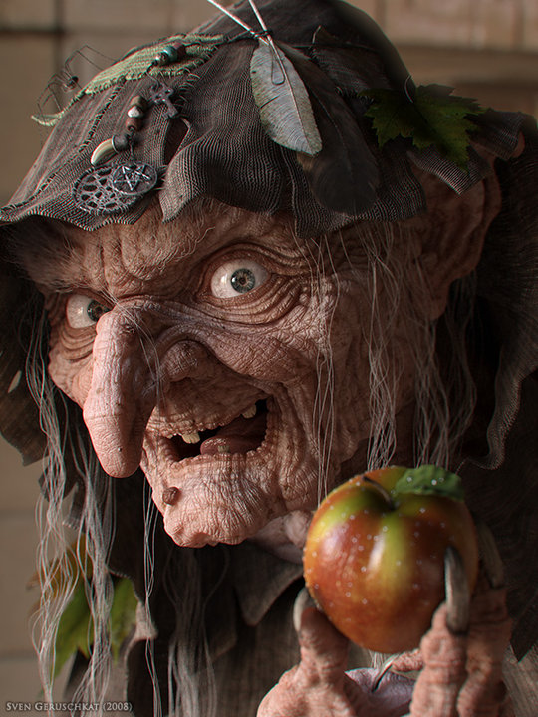
Now the Russian clubs and bars are the most popular places for celebrating of Halloween. Almost every club in every Russian city prepares its own programme, usually consisting of dances, special "scary" menu, thematic show programs, fire shows and contests for the best costume. The clubs are decorated just as every club in Europe or the USA, with ever-present Jack-o-lanterns, black candles, and other "cute" stuff.
Young people like to walk in Halloween costumes in the city's streets, so they often hold improvised procession of vampires, zombies, witches and other "evil spirits". Several years ago all the costumes were handmade, as there weren't any places to buy it, so people had to make them from anything at hand. Now the situation is better, and there is no problem with buying costumes, masks and other accessories through numerous online stores. But many people still prefer to make costumes and make-up themselves, as it is much more interesting.
Of course, Halloween in Russia could not get on without a unique national colouring. Russian folklore is rich with scary fairy-tales, legends and insidious evil spirits, who usually oppose a herioc protagonist. So Russians use these stories and characters during celebrations, creating unique costumes and even playing short scenes from favourite films and books. By the way, look at the right image: surely Baba-Yaga is so pretty!
National and military Russian costumes are very popular too, with fur-hats, felt boots and even toy Kalashnikovs. The other popular style is costumes of some famous tsars or politicians, like Stalin, Lenin, Ivan the Terrible, or Rasputin. But the most popular is...well, you know...the Russia's current prime-minister. Don't be frightened if you see five PMs drinking together in a Moscow club.
So, what does Halloween mean for Russians? Most Russian people never celebrate this holiday and don't know anything about it. For others it is just another cause to have some fun, to do something new and exotic, to show their creativity, to become a bit closer to the foreign culture and traditions. Halloween in Russia was revealed, supported, welcomed, blamed, prohibited, used for different reasons, but still never forgotten. And it looks like it is not the last page in its history. Well, let it be more funny than scary. Trick or Treat!
According to the official statistics of sociologist from «Levada Centre», for the last five years the number of people who don’t anything know about this holiday, has decreased from 46% to 27%.
Only 6% of Russians knowing about Halloween, are going to celebrate it ( compared with 4% in 2006).
So, according to this survey, the number of people who are somehow interested in this holiday, is increasing.
Should we be satisfied with this fact, or is there any thread in this rapid growth of popularity?
We’d like to consider different points of view on the problem.

Survey
I have interviewed students, studying at our school and their parents. The results of this review are shown in these pie-diagrams.
1. Have you ever celebrated Halloween?
The majority (66%) of the respondents have never celebrated Halloween. The 24% always celebrate Halloween, others would like to try it.
2. How do you feel about Halloween in Russia?

3. Is there alternative to Halloween in Russian holidays?
I also ask my foreign penpals how popular Halloween is in their country and if they celebrate this holiday.
There are some answers of them:
- “Well, people used to celebrate it, but it's more commercial than traditional and folkloric.Halloween isn't a french traditional stuff but an imported stuff”- answer a men from France
- “Unfortunately, we've never celebrated it. We in Serbia do not have that custom. I think it should not be celebrated in Serbia. It is a western custom of consumer...”- said women from Serbia
- “Nooo we don't celebrate holloween here in india:( I’d like we celebrate this,its a nice festival” answered a boy from India
- “when i was younger I celebrated it,
- and I think it should be celebrated nowhere!” – admitted a boy from Germany

What do the supporters and the opponents of this tradition say? Let’s regard their opinions more precisely.
Opinions “for”
For children, Halloween means fun. It is a time when they could go out in their spookiest costumes. They could gather together with other kids and roam the neighborhood, still in costumes, to go trick or treating. This way, they not only have fun wearing costumes. They even get to collect and gather candies, goods, and even coins from homeowners. Households love the idea of having to deal with fun children who are threatening to do a mischief if not given treats. This tradition has become customary. And so logically, for most children, Halloween is fun.
For teenagers, Halloween is an opportunity to socialize with their peers. They could gather to help adults and their parents organize and run up a timely Halloween party. They could enjoy the party with their crushes. It may be a fun time to get along with cliques. They could dance the night away and enjoy sumptuous foods.
Some psychologists say that Halloween is an attempt to ridicule the feeling of fear. Through the collective laughing at the fear of death, people gain psychological calming in front of “the other world”.

Opinions “Against”
People who don’t approve of celebrating Halloween in Russia, believe that this holiday won’t stay here long. The traditions of Halloween, such as carnivals, wearing costumes of the evil spirits, worship of the dead, are not common to the Russian culture.
The celebration of Halloween is just a commertial project, that more than suits owners of costume stores and entertainment venues. "It is the most fun and colorful show of the year. On Halloween night, we are always sold out and there's always a positive atmosphere. Only New Year can compete," says Alexander, an administrator at a Moscow night club. Year on year, the most popular costumes in late October are zombies, Dracula, black nurses, pirates, sailors, witches, devils, fairy-tale characters, vampires, and horror villains.

There is also a point of view that Halloween and other borrowed holidays make Russians forget their roots and traditions Russian people should think more of their own national holidays and give less attention to festivities of foreign origin, like Halloween, a clergyman of Moscow Patriarchy of the Russian Orthodox Church told Interfax.
“The celebration of Halloween in Russia has become quite popular. This fact shows that we should be more careful with borrowing foreign holidays. It also proves that Russians can be culturally omnivorous, although we should value our own national traditions and customs. I believe that this is a very sad tendency,” priest Mikhail Prokopenko said.
The clergyman believes that Russian people can easily forget about their national roots and follow customs, rules and traditions of a different culture or religion.
“We have to realize that Halloween is just a masquerade, an entertainment which may often imply commercial interest when shops sell their entire stock in a couple of days. Nevertheless, a young man or a woman, who dress like vampires or demons, are led to believe that they can display monsters’ qualities in real life,” Mikhail Prokopenko said.
Indeed, Halloween has been gaining more and more popularity in Russia during the recent years. The celebration of this holiday often takes place at public schools and even kindergartens of Russia.

Russian Orthodox Church harshly condemns Halloween for its cult of death.
It expressed its concerns in connection with the modern tradition to celebrate Halloween. “Times have changed a lot nowadays. The innocent amusement has been replaced with the entertainment industry, which tends to take dark and mystical coloring,” an article by Mikhail Dudko, a priest of the Uspensky Cathedral in London said.
Speaking about the modern tradition to celebrate Halloween, the cleric said that normal piety has been replaced with commercial dismay. “Our ancestors would think that Europe disavowed Jesus Christ and started worshipping Satan,” the priest wrote.
“Old Christian nations of the continent used to entertain themselves with the contrast of their children’s innocent faces and pumpkins which only symbolized the evil defeated by Christ. Nowadays the true evil gradually comes to a reign,” Mikhail Dudko wrote.
To exemplify his point of view, the priest resorts to the film titled Halloween. The film tells of a little boy, who murdered his six-year-old sister on the eve of Halloween and then became a blood-thirsty killer. The Russian Orthodox Church has repeatedly expressed that its improper for Russian men, women and especially kids to dress like vampires or demons, pretending to display monsters’ qualities in real life.
That opinion is partially supported by some patriots who say Russian people should stick to their own national holidays and give less attention to festivities of foreign origin, like Halloween. They believe that Russian people can easily forget about their national roots and follow customs, rules and traditions of a different culture or religion.
In the meantime, spokespeople for the Department of Education in Moscow say that Russian schools must not organize any events devoted to Halloween. The position of the department has remained unchanged since 2003, when the administration signed a letter to headmasters of Moscow schools asking them not to hold any events dedicated to Halloween. The official said that such decision was made in connection with religious aspects of the holiday – the cult of death, gloating over death, the personification of evil spirits, etc., which statement obviously contradicts the secular character of education of state-run schools in Russia. However, according to some witnesses from Russian schools, the prohibition is not strictly supported by all schools, and some of them let pupils organize the most neutral events. And the number of such schools increases every year.
In Russia Halloween even became a part of political protests. Thus, in 2008, more than 20,000 activists of one pro-Kremlin youth movement held an action of protest in front of the US Embassy in Moscow. Each activist was holding the traditional Halloween pumpkin heads with burning candles, as a symbol of those people those who fell victims to the foreign politics of the United States.

Ruth Edna Kelley, The Book of Hallowe'en, Boston: Lothrop, Lee and Shepard Co., 1919, chapter 15, p.127. "Hallowe'en in America."
Irish: báirín breac
spelling and punctuation preserved
http://english.pravda.ru/history/01-11-2007/99982-halloween-0/

