Municipal Educational Establishment Secondary School №1

Nizhegorodskaya Oblast Pavlovo

**Like Master Like Dog**

   Carried out by a pupil:

Klimchuk Svetlana (13 years old)

                                                                                                                                                 Scientific adviser:

                                                                                                                   Molodtsova.E.S

Pavlovo, 2018

**Contents**

Introduction……………………………………………………………. 3

Dogs in Britain and Russia …………………………………………… 4

Attitude to dogs in Great Britain and Russia ………………………….. 6

How the dogs are treated in The UK and Russia……………………….8

My research. People’s opinion about animal protection………………..9

Conclusion …………………………………………………………….12

List of literature…………………………………………………………13

**Introduction**

The topic of my research is “Like master like dog”. It is generally agreed today that dogs help people and this help is really useful. Since the days of BC dogs and humans have been living together and helping each other. The relationship between man and dog is a mutual exchange. A dog teaches people loyalty, ability to love. Taking care of his pet, the teenager learns independence, responsibility. It will certainly help him in future life – studying, making friends, work.

On the other hand, sometimes people forget that dogs are their best friends. Violence and cruelty towards dogs as well as the number of stray dogs is huge in different countries.

**Actuality**

I think that this topic is interesting because almost every teenager dreams about a dog, but not everyone is aware of the importance of acquiring a dog. Moreover, the topic is very acute nowadays because of the wide discussion of the bill on the protection of animals in Russia, which cannot be passed in our Duma despite of the fact that it is so much desired and necessary in our society.

**Hypothesis**:

People all over the world breed dogs, but in each country there is different attitude to them.

**The aim of my research:**

To compare the attitude to dogs and other pets in Great Britain and Russia

**The objectives:**

* to analyze the statistics about dogs in the United Kingdom and Russia
* to point out the reasons of overweigh and obesity in both countries
* to analyze differences and similarities of Russian and British way of treating pets
* to gather information about the attitude to dogs among the students of our school
* to analyze the information and arrange it in the form of a diagram
* to present the results of the comparison in a comparative table

The methods of my research:

* Interviewing
* Analysis
* Comparing
* Studying literature on the topic

**Dogs in Britain and Russia**

A man’s great inseparable friend has always been a dog. It plays a great role in the British family. The country has a vast range of British dog breeds. The medium-size British Bulldog is one of them. Its face has wrinkled skin which gives it a fierce look. Breeding standards of the Bulldog are typically set by the UK Kennel Club, American Kennel Club, and United Kennel Club.

Easy to train, courageous, always playful and a very patient animal is the Cavalier King Charles Spaniel. It is another favourite dog among the dog breeds. Owners find this type very affectionate and sociable.

Another favourite type of British dogs is The English Setter that comes from the Setter family. Others in the Setters include Irish Red and White, and Gordon Setters.

Covered with long fur, the Old English sheepdog is one of the large British-bred dogs. Its eyes and face are covered with coats of long fur giving them a lovely appearance. It is very playful but highly intelligent, loving and easy to be among people.

The English springer spaniel is very small. It is a type of gun dog and traditionally used in hunting for flushing and retrieving.

Another dog breed of British origin that enjoys high popularity is the Staffordshire bull terrier. It is short and medium sized. Its fur is short, and the body is muscular. The owners of this type have no complaints about it. Instead, they say this type is very loyal.

Among the other popular breeds of British dogs that are the Bull Terrier, Yorkshire terrier, and Otter hound, Pembroke Welsh Corgi, English Cocker Spaniel, and the Border collie. There are also, the English Mastiff, English foxhound, Airedale Terrier, Pointer, Beagle, Shetland sheepdog, Golden Retriever, American Pit Bull Terrier, and King Charles spaniel.

Before the Russian Revolution, Russia was known for two things, herding and hunting. Subsequently, the dog breeds used by the people were herding breeds, guard breeds and hunting breeds. The aristocrats were dog lovers, breeding dogs such as Bolonkas and Borzois for their beauty and companionship. In the northern part of the country, they were using Laikas for both hunting and sledding, while in the southern part of the country the Russian Sheep Dog and the Central Asian Dog were doing a good job of guarding the flocks and herds that were grazing on the pastures. Two of the main characteristics of the dogs from this era is intelligence and loyalty, the 2 traits that were a must in order for these dogs to perform well. Luckily for us, these traits have not been lost, and individuals from these breeds will display them even today. One of the pre-soviet dog breeds that stands out is the Laika, which translated from Russian means “the barker”. This particular breed can still be found to this day. They were used as guard dogs, herding dogs, hunting dogs, sled dogs.

During Soviet time, for almost a century, the thick iron curtain of communism has affected the entire world, and dogs are no exception. They have been hit hard by the social changes, and in ways that are unfathomable to us now. “Such typical Russian breeds as the Samoyed, the Borzois and the Bolonkas were considered “aristocratic toys” and “useless playthings”, and have subsequently been deemed unfit to be a part of the new socialist order. The poor dogs were ousted and chased away in order to make room for the new working dog breeds, dogs that were supposed to work side by side with man in order to achieve the goals of the communism.”[1]

These breeds have been saved from extinction just thanks to dog lovers from Western Europe and the United States The Samoyed managed These breeds have been saved from extinction just thanks to dog lovers from Western Europe and the United States.

The Samoyed managed to weave its way in by the skin of its teeth as a sled dog though, and the breed has managed to remain a part of Russian life throughout those dark years, and the breed has managed to remain a part of Russian life throughout those dark years.

Not all stories have a happy ending though. The Russian Newfoundland, a breed specifically created for Russian life, was declared extinct in the 1980s, and, there might be a lot of breeds that we don’t know about that are now extinct as a result of the reforms in place at the time.

Nowadays, even though Russian dogs are starting to gain traction and a substantial increase in popularity, these breeds are still fairly rare, and as such most of them are not yet recognized by international kennel clubs, nor standardized by them. The only exceptions are the Russian black Terrier and the Russian Toy, due to their popularity and their spread around the world.

**Attitude to dogs in Great Britain and Russia**

**Great Britain**

The British say that in their country the animals have more rights than children. Maybe this is not quite true, but animals, and especially dogs, are appreciated and treated with love and care. In the UK there is Royal society for the protection of dogs, a blood Bank for dogs and restaurants for dogs.

The UK was the country which gave birth to bloody entertainments (bull fights and dog fights), but it also became the first country that approached to the animal law in the world. The Britain government announces that the animals are not wares for human to use, but are the nature life and gave the promise that they will provide the highest qualities of animal welfare in Britain. Therefore, in 1781, the first law connecting to animals was passed in London. In 1822, the first parliamentary law for animal welfare in the world: Richard Martin’s Act to *Prevent the Cruel and Improper Treatment of Cattle* was passed by the British Parliament. Moreover, the Protection of Animals Act was passed in the UK, which unified all the previous animal protection legislation in 1911. Richard Martin was the founder of the Royal society of the protection of animals (Royal Society for the Prevention of Cruelty to Animals - RSPCA). Currently, there is a big number of charity organizations, funds, societies, movements for the prevention cruelty to animals. All of them provide high level of animals protection in the U.K.

In 2005 in Great Britain the first blood bank for dogs was created. “It is a charitable organization for the collection, processing, storage and delivery of blood of animals. The Bank of blood of the animals is open to all veterinarians in Britain. The dog must be healthy, vaccinated, and good-tempered, aged 1-8 years old and weigh not more than 25 kg”[2].

London restaurants offer a menu for dogs. Bluebird restauront located in the city centre, serves food not only for humans but for dogs. In a special dog menu there are lamb chops with mashed potatoes and a pasta "Penne" with bacon. From drinks they offer cocktail "Dog hair" (Guinness beer with milk). Four-legged visitors eat outdoors, in the restaurant’s yard. According to veterinarians, dogs should eat special food because human food can be harmful for their health.

The patron saint of stray dogs in Europe is Saint Bernard. But there is no use in term “stray dog” in the UK, as there are practically none of them left in the UK. They are called dog Bernard. In the UK the attitude to unattended dogs in the streets is very serious. The decision is a microchip as the means of saving the problem with homeless animals.

All dog owners in England are obliged to implant their pets with a microchips that contain information about the owner. Thus the authorities plan to reduce the number of homeless animals. A microchip the size of a grain of rice allows you to return to the owners their stolen or lost pets. If, despite all the measures taken, a homeless dog is found, it will be taken to a shelter for dogs of "Royal society of protection of animals". In addition, the owners bear a legal responsibility if their pet,for example, has become the reason of a road accident or attacked a postman. If the owner of the dog ignores the law and doesn’t chip the pet, there are high penalties up to £ 500.

**Russia**

In Russia dogs are not less popular than in England, but there are much more problems with their keeping and protecting. First of all, the cultural level of keeping and maintaining is rather low, there are no special places for walking, the number of stray dogs is huge, and the cruelty towards them is striking. However, these problems are tried to be solved.

From the Russian newspaper "Nedelya", I’ve learned that the citizens, wished to solve the problem of homeless animals by humane methods.80% respondents surveyed on the website of the city administration, voted for humane solving of the problems of stray animals. 30% believe that it is necessary to build shelters for animals and euthanize only aggressive dogs, 28 % supported the idea of of penalties for dog owners for throwing them away into the street . Only 18% voted in favor of the trapping and euthanasia of dogs. In Nizhny Novgorod there are several shelters for dogs already, for example, "Fauna-NN".

Stray dogs are a threat to the people. The majority of Russians – 80% (survey by the Levada center) believes that homeless animals in the streets is the result of the irresponsibility of the their owners.

**How the dogs are treated in The UK and Russia**

The British say that in their country the animals have more rights than children. Animals, and especially dogs, are appreciated and treated with love and care. In Russia dogs are not less popular than in England, but there are more problems with their keeping and protecting. The cultural level of keeping is low and the cruelty to them is striking. However, these problems are tried to be solved..

This is the result of comparison of attitude to animals in Britain and Russia.

|  |  |
| --- | --- |
| Dogs in the UK | Dogs in Russia |
| There are special places for dog walking | There are no such places |
| There is Royal Society for the Prevention of Cruelty to Animals and other societies protecting animals’ rights | We have only volunteers’ societies |
| The first in the world Blood bank for dogs is opened | There is no blood bank |
| Shelters for dogs are all over the country | Shelters have just appeared |
| There are practically no stray dogs. They are all put into shelters or adopted into a family | There is more than a million stray dogs, but there is no exact statistics |
| Sterilization and chipping is obligatory | Sterilization is only in some parts of the country |
| There are restaurants for dogs | No restaurants |
| Trapping and killing dogs is forbidden | Trapping, killing, poisoning or euthanasia of homeless dogs is common |
| There are penalties for impropriate treatment of pets | No penalties |
| The Protection of Animals Act has been working since 1911 | There is still no law protecting animals. |

As you can see from the table. dogs are loved in both countries. But the attitude to them is different because of differences in cultural tradition, government policy and legal system. The animals in Great Britain are protected by law, cared by people and financed by the government.

Russia, on the contrary, doesn’t have any government policy on the animal protection or laws preventing cruel attitude to animals. A lot of work is done by volunteers. But they are not supported by the state and cannot cope with the problem alone.

**My research. People’s opinion about animal protection**

I have made a survey to study the attitude of the local community to the problem. I interviewed 50 people. Here’s the result of my survey.

1.Is animal protection important? 100% respondents agree with it.

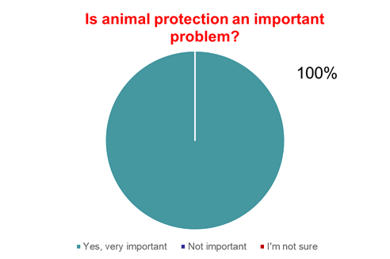

2.What is the most effective way of animal protection?

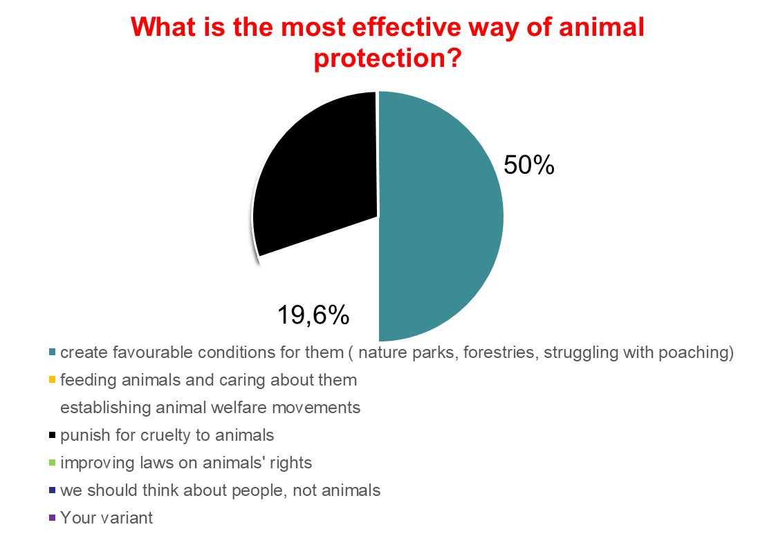

Most people(50%) name creating favourable conditions (nature parks, reserves, shelters), punishing for cruel attitude to animals (30%) and establishing welfare movements (19.6%).

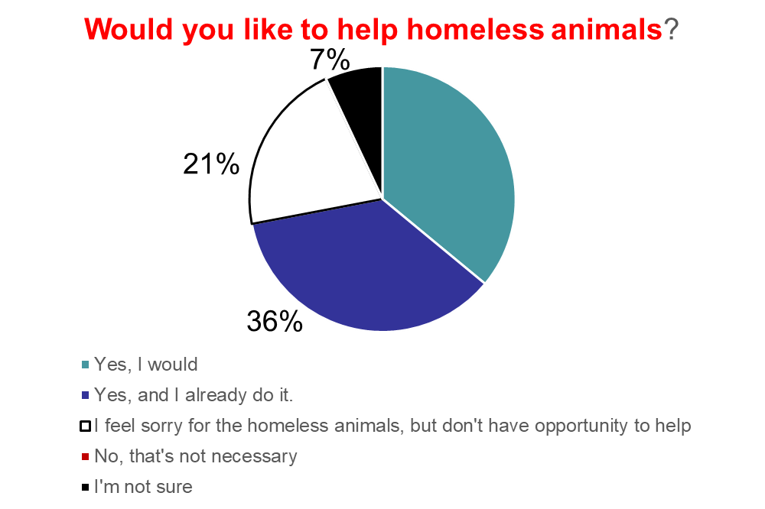3.Would you like to help homeless animals?

36% respondents would like to help or already do it.

4.Do you distribute information about animals who need help? 100% of respondents do it regularly.

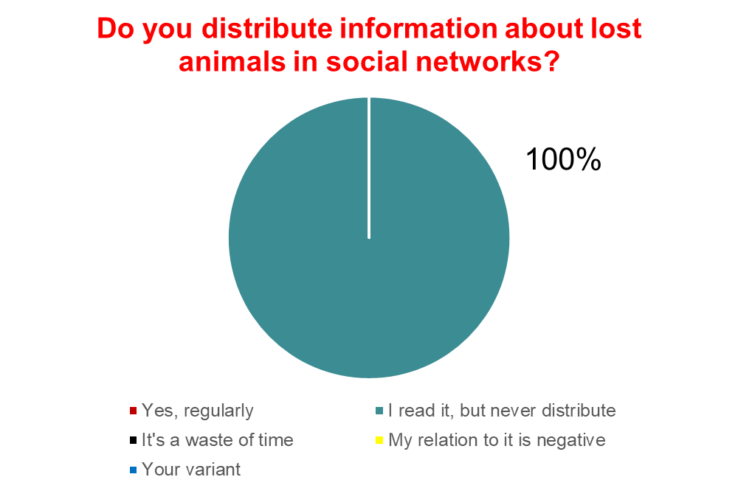

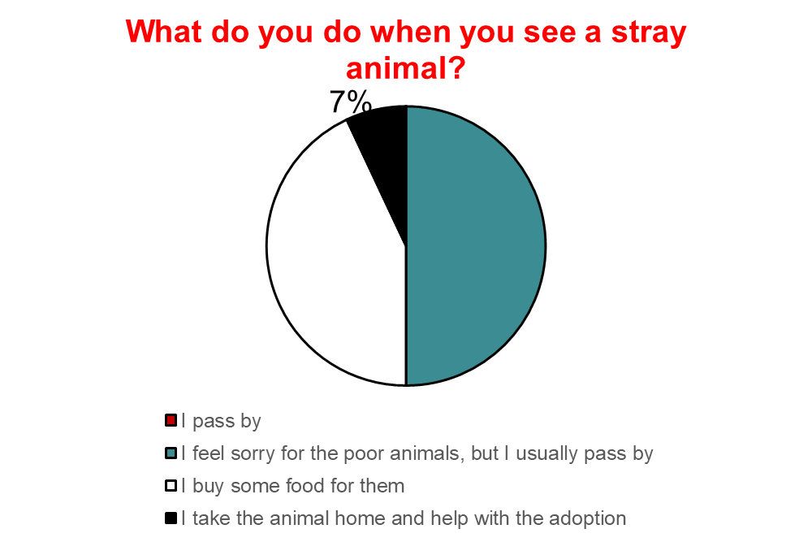5. What do you do when you see a stray animal?

Only 7 % will try to find a shelter or adopt it. Most of them will pass by.

The survey reveals that most people understand the importance of helping homeless animals, but only few of them do something really significant.

Conclusion

To sum up, my hypothesis has been proved. On the example of Russia and Great Britain, can very clearly see the difference between the culture, traditions, ways of breeding dogs, as well as the attitude of people, government and the whole society to their treatment.

**List of Literature**

1. Домашние животные/Пер. с англ. О. Кутуминой. – М.:ТЕРРА, 1997. – 136с.
2. Журнал «The DOG collection» №10
3. Журнал «The DOG collection» №21
4. Журнал «The DOG collection» №22
5. Журнал «The DOG collection» №27
6. "Российская газета - Неделя" - Приволжье №6816 от 29 октября 2015 г.
7. [www.top-antropos.com](http://www.top-antropos.com)
8. [www.dogs.dreval.com](http://www.dogs.dreval.com)
9. <http://english2017.ru/talking-about-pets-explanations>
10. Аналитический центр Юрия Левады: [www.levada.ru](http://www.levada.ru)
11. [www.sobakino.com](http://www.sobakino.com)
12. Russian dog breeds: <http://dogsaholic.com/breeds/info/russian-dog-breeds.html>
13. Закон о защите животных: реалии и перспективы:

<http://subsidii.net/%D0%B5%D1%89%D1%91-%D0%B2%D1%8B%D0%BF%D0%BB%D0%B0%D1%82%D1%8B/%D0%BD%D0%BE%D0%B2%D0%BE%D1%81%D1%82%D0%B8-%D0%BE-%D1%80%D0%B0%D0%B7%D0%BD%D0%BE%D0%BC/item/1052-%D0%B7%D0%B0%D0%BA%D0%BE%D0%BD-%D0%BE-%D0%B7%D0%B0%D1%89%D0%B8%D1%82%D0%B5-%D0%B6%D0%B8%D0%B2%D0%BE%D1%82%D0%BD%D1%8B%D1%85.html>

1. Dogs in British history and modern Britain <https://otherreferats.allbest.ru/languages/00379854_0.html>

1. Russian dog breeds: <http://dogsaholic.com/breeds/info/russian-dog-breeds.html>
2. <https://otherreferats.allbest.ru/languages/00379854_0.html>