Municipal Educational Establishment
Secondary School №1
Pavlovo Nizhegorodskaya Oblast

Superstitions in Russia and Great Britain

Carried out by a pupil:
Maslagina Olga, 10 form
(15 years old)

Scientific adviser:
Molodtsova.E.С.

Pavlovo
2012

Contents
- Introduction………………………………3
- What is a superstition…………………….4
- The origin of superstitions………………..5
- People’s opinions about superstitions…… 7
- Superstitions and holidays………………..7
- Superstitions and flowers ………………..9
- Wedding superstitions…………………...10
- Other superstitions………………………12
- Superstitions and professions……………13
- Conclusion……………………………….15
- List of literature………………………….16
- Appendix…………………………………17

Introduction.
There is a good English saying: “So many countries so many customs.” Every country and every nation is rich in traditions and customs which comprise the culture of this nation. People keep and save their traditions, and the largest part of the traditions is connected with national customs and ceremonies. A great number of customs and traditions date back to the early days, and we can justly say that they are the reflection of the country’s history and the people’s psychology. To know the customs and traditions means to understand the people, their art and culture better. Among people’s traditions and customs, we often come across superstitions and prejudices which people can believe or not, but still, they are part of our life, history and culture.
In my research work I am going to point out the differences and similarities of Russian and English superstitions and prejudices.
The main aims of the work are:
- to analyze the world of the superstitions of the UK and Russia
- to learn about the origins of some superstitions that now seem odd and irrational
- to analyze differences and similarities of Russian and English superstitions and prejudices
- to gather information about the most common superstitions among the people of different age groups
- to analyze the information and arrange it in the form of a diagram
- to analyze and compare the results of the survey which we made among their relations and friends
The methods of my research:
- Interviewing
- Analysis
- Comparing
- Studying literature on the topic

What is a superstition?
“Superstition is a credulous belief or notion, not based on reason or knowledge. The word is often used pejoratively to refer to folk beliefs deemed irrational, which is appropriate since irrational means "not based on reason". This leads to some superstitions being called "old wives' tales". It is also commonly applied to beliefs and practices surrounding luck, prophecy and spiritual beings, particularly the irrational belief that future events can be foretold by specific unrelated prior events”.Almost every nation has a reputation of some kind .People have believed in superstitions from the dawn of time. Pre-historic man feared great natural powers, and phenomena that he did not understand, and related them to the gods, spirits, good and evil forces that control the world. He tried to invent ways to hold back the forces of evil and from this, in actual fact, superstition was born. Over the years, man’s beliefs changed, and so too did the superstitions, but they did not disappear. Many have been preserved to this day, and the rationale behind them has been forgotten and has disappeared. Superstitions can be defined as, "irrational beliefs, especially with regard to the unknown"(Collins English Dictionary).They cause us to act in strange ways, believe in odd things and leave us unable to explain the reasons why. Many superstitions may seem silly, even stupid to us today, but they continue to influence our behavior.
There are different groups of superstitions:

- Superstitions and professions
- Superstitions and holidays

- Superstitions and flowers

- Wedding superstitions

The origin of superstitions
The term superstition came from the Latin superstitio, meaning "to stand over in awe." Superstitious beliefs originated during the earliest days of humanity. Faced with natural phenomena like thunderstorms and earthquakes, as well as the unpredictability of illness and food supply, human beings created an understandable world of powers that could be influenced by action. The earliest superstitions were created as a way to deal with the fear of the unknown. Superstitions are thus a way of attempting to take control over events, when one feels helpless.
Often, superstitions are born from casual coincidence. For example, if an athlete wears a particular pair of socks on a day he performs particularly well, he may continue to wear the same pair of socks in the belief that the socks were responsible for the success. Future successes reinforce such a belief. In some cases, it is certainly possible that the simple belief in success or failure can influence the outcome. The athlete who cannot find his "lucky socks" may, due to lack of confidence, perform poorly, further reinforcing the belief in the power of the socks.
We tried to choose the most wide-spread superstitions both in Russia and Britain and compare them, point out their similarities and differences.
In Russia there is a superstition that if a black cat crosses your way, it’s a bad luck.
In Great Britain, it’s just the opposite. To meet a black cat means success and good luck. This superstition goes back to the Ancient Egypt, where a cat was a sacred animal and it kept the house and the people who lived there safe and brought peace.
There are a lot of superstitions dealing with birth and death of people, with their wedding and christening. Thus, in Russia many centuries ago a bride should have worn a red dress, not white. “Red” meant “beautiful” («красный» - «красивый»).
In England a bride wore a blue dress, because “blue” meant “true”, “pure”, “sincere”, from the English “True blue”, which means «голубая правда, истина» Only later, under the influence of Greek culture, a wedding costume became white both in Russia and in Great Britain, as this colour in Greece was a colour of innocence and holiness.
In Russia there is a tradition for a bride to wear a brand-new dress, because it is considered that if she wears somebody else’s clothes, she “puts on” somebody else’s fortune and destiny. In Great Britain a bride should wear, as they say, “something old and something new, something borrowed and something blue”. If she follows this rule, her life is sure to be happy.
But in both countries there is a belief that it is not lucky to marry in May, especially on Friday and on the 13th. In Russia it is connected with the pronunciation of the word «Май» - «маяться». In England May is the month to make a sacrifice and wear mourning.

People`s opinions about superstitions
I have interviewed one hundred people living in my native town of different ages and sexes to know their attitude to superstitions.

Questions:
  - Do you believe in superstitions?
  - What superstitions do you believe in?
  - Have your superstitions ever come true?
  - What is men’s and women’s attitude to superstitions?
  - The results of the survey are organized in a form of diagrammes.
(See Appendix1)

Superstitions and holidays
I can guess that there are a lot of various superstitions which are connected with Christmas and New Year’s Day. Most of them have roots in long – ago times. To my mind, it’s very useful and interesting to analyze their difficulties and similarities in Britain and Russia.
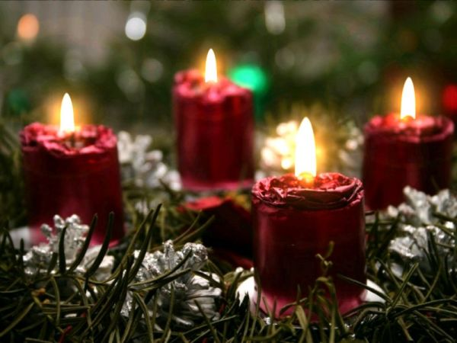
Superstitions from Britain:
Christmas superstitions
- If the wind is blowing on Christmas Day, you are in for a good year.
- If you want to have good health throughout the next year, eat an apple on Christmas Eve.
- If you want to be happy, eat Christmas pudding on Christmas Day.
- If you wear new shoes on Christmas Day, it will bring you bad luck.
- If you refuse a mince pie at Christmas dinner, you will have bad luck for the coming day.
- If you cut a mince pie, you'll "cut your luck" too.
- If a baby is born on Christmas Day, it will have special fortune.
- You will have as many happy months in the coming year, as the number of houses you eat mince pies in during Christmas time.
Christmas pudding
It is said puddings should be prepared with 13 ingredients to represent Christ and His Disciples
Traditionally, it's lucky to help make the pudding — so every member of the family takes turns to stir the pudding and make a wish. But to preserve good luck, the pudding should be stirred clockwise and with a wooden spoon.
Putting a silver coin in the pudding is another age-old custom that is said to bring wealth, health and happiness to the lucky person who finds it.
New Year superstitions
- If the first visitor at your house on New Year's Day is an unknown dark-haired man, then a year of good luck will follow.
- If the first visitor has red hair, it's extremely unlucky. The arrival of a woman is total disaster.
- If you cry on New Year’s Day, you'll be crying all the year.
- If you lend anything on New Year's Day, you'll be lending all the year.
- If you wash your hair on New Year's Day, you'll wash away good luck.
- If you are in debt and don't pay your debts before New Year's Day, you'll be in debt all the year.
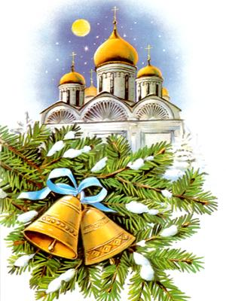
- If you sweep the floor or dust the furniture on New Year's Day, good fortune will be swept away.
Superstitions from Russia:
Christmas Superstitions
- If you feed birds outside the house, you will be happy in the following year
- You’ll be unhappy if your first guest is a woman
- It is recommend to serve 12 kinds of food
New Year’s Day
- It’s unlucky to break dishes because it can lead to arguments
- If you are not polite to guests, you won’t have money in the following year.
- You should forgive enemies
- You should put a wreath on your door
- You have to use a white tablecloth because it means kindness and grace
- If you go to bed early, you will miss your happiness
- You should leave a glass of wine and a spoon on the table for a brownie
Superstitions and flowers
- Holly:The holly tree was known to medieval monks as the "Holy Tree"
because it was believed to keep evil spirits away. It was also believed
to protect a home from lightening.
- Lily: In Christianity the lily represents purity, chastity, and innocence. White lily bouquets are especially popular in Christian homes during the Easter holiday. Legend says that the lily sprang from Eve's tears, when upon being expelled from Eden she learned she was pregnant. Planting lilies in a garden will protect the garden from ghosts and evil spirits. Russians also believe that Lily is a flower which brings unhappiness.
- Rose: The rose is the flower emblem of England. If the petals fall from a fresh-cut red rose, bad luck will soon follow. The red rose is the badge of the House of Lancaster and the flower of Eros and Cupid. The white rose is the badge of the House of York and the flower of the Virgin Mary. However, Russians think that the rose is a symbol of grace, beauty and pride.
- Clover: Clover usually has three leaves, but a few have four. In both countries, Russia and Britain, a clover with four leaves is supposed to bring good luck.
Wedding superstitions.
There are so many customs and superstitions
associated with weddings. A lot of wedding traditions go back to folklore and
Pre-Christian times and used to protect marrying couples against bad luck and
evil spirits.
Britain:
In the past young people could not just fall in love and decide to get married. First, they needed to obtain their parents' consent.
The groom didn’t propose in himself but sent his friends or members of his family to represent his interests to the bride and her family. If on the way they saw a blind man, a monk or a pregnant woman during their journey, it was believed that the proposal would not be accepted. If, however, they saw wolves, it was a good sign. The most popular day for wedding is Saturday. In the past, however, choosing when to marry was a serious affair. Saturdays were unlucky, and so were Fridays, especially Friday the 13th. This famous old rhyme advises a wedding to happen in the first half of the week:

Monday for wealth
Tuesday for health
Wednesday the best day of all
Thursday for losses
Friday for crosses
Saturday for no luck at all
Another belief deals with the bride’s outfit. It is reflected in this old rhyme, which is as relevant today as it was more than a hundred years ago:
Something old, something new
Something borrowed, something blue
And a silver sixpence in your shoe
"Something old" is usually given to the bride by a happily married woman in the hope that her happy marriage will be passed on to the new bride. "Something new" symbolizes the newlyweds' happy and prosperous future. "Something borrowed" is often a valuable item lent by the bride's family which needs to be returned to ensure good luck. "Something blue" is normally a blue ribbon in the bride's hair to symbolize fidelity. The placing of a silver sixpence (an old English coin) or a penny in the bride’s shoe is to ensure future wealth. The last part of the wedding is the reception. Traditionally, guests are offered a wedding cake. Originally, cakes were flat and round and contained fruit and nuts that symbolized fertility. Now wedding cakes have three tiers. The new shape is believed to have been inspired by the unusual spire of Saint Bride's Church in the City of London. The couple makes the first cut together to symbolize their shared future. It is said that if unmarried guests place a piece of wedding cake under their pillow before sleeping, it will increase their chances of finding a partner.
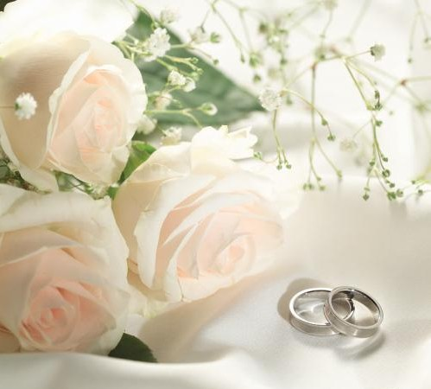
Russia:
Most wedding ceremonies involve an exchange of wedding vows by the couple, presentation of a gift (offering, ring(s), symbolic item, flowers, money), and a public proclamation of marriage by an authority person or leader. Special wedding garments are often worn, and the ceremony is followed by a wedding reception. A number of cultures have adopted the traditional Western custom of the white wedding, in which a bride wears a white wedding dress and veil. The use of a wedding ring has long been part of religious weddings in Europe and America, but the origin of the tradition is unclear. Historians like Vicki Howard point out that belief in the "ancient" quality of the practice are most likely a modern invention. "Double ring" ceremonies are also a modern practice, a groom's wedding band not appearing in the United States until the early 20th century. The wedding is often followed by a reception, in which the rituals may include toasting the newlyweds, their first dance as spouses, and the cutting of a wedding cake.
Other superstitions
Britain | Russia
- It's extremely unlucky to walk under a ladder  - It's unlucky to spill salt.  - The number 13 is very unlucky and Friday 13th is the most unlucky day. | - It`s unlucky to walk under a ladder  - It`s a bad sign to spill salt in Russia too  - Number 13 brings unhappiness

Superstitions and professions
I`d like to find out similarities and difficulties of actors` signs and omens in Russia and in England because thespians are known for their superstitious nature. Some of their superstitions are normal, others are crazy, but all of them are very interesting
Britain | Russia
- Do not wish other actor good luck – instead say “Break a leg”. This comes from "bending a knee" (for taking a bow).  - It is bad luck for an actor to receive flowers before the play begins, though flowers given after the play has ended is considered good luck.  - Only fake flowers will be used on stage.  - It is unlucky to use real mirrors or real jewelers onstage, because both items can cause problems with the onstage lighting, so fake mirrors and jeweler should be used. | 1.This superstition is connected with screen version. Actors are sure that they mustn’t drop it. If they do it, they will have to sit on it for some seconds, then take it and stand up. Actors claim that Actors claim that unless they do it, they’ll fail acts.  2. There are no make – up rooms number 13 in theatres.  3.Actors don`t put pictures up on the doors of their make – up rooms. They think that those pictures bring unhappiness.  4.Actors don`t put pictures up on the doors of their make – up rooms. They think that those pictures bring unhappiness
Britain | Russia
- It is considered bad luck to speak the last line of the play any time before opening night. This is because a production is never complete until it's performed for an audience, so the completing line of the play shouldn't be spoken before an audience sees the play.  - If an actress trips on the hem of her dress, she should pick it up and kiss the hem for good luck.  - You should not whistle while you're in the theatre, especially in the dressing rooms. It is said that someone will soon be out of work if whistling occurs in the theatre.  - Monday night is considered Ghost Night. Most theatres don't have productions on this night so the ghosts will have their own night to perform their plays.  - Probably the most well-known superstition involves William Shakespeare’s Macbeth. The superstition says that any group putting on this play will suffer bad luck, ranging from minor mishaps to major catastrophes! | - Actors don`t put pictures up on the doors of their make – up rooms. They think that those pictures bring unhappiness.  - It`ll bring unhappiness if there is spilled make – up on actor`s tables.  - If actors give their soap to someone, they will give him/her their luck.  - The bad omen is a cat which is crossing scene during rehearsal, but if that cat cross that scene during the performance, it’ll be lucky for actors.  - If actors find a nail, he will be offered a new role soon.  - It`s unlucky to use flowers decorating scenes.  - Actors mustn`t whistle in theatres, because it can cause absence of performances there.  - Michael Bulgakov`s Master and Margarita and Nikolai Gogol`s Viy are well – known superstitions. They bring unhappiness as William Shakespeare’s Macbeth.  - It is also unlucky to act someone who will die in the film or performance.

Conclusion
It is easy to understand that superstitions are important for us. We all know that they have been existing since Ancient period of time. Everybody knows that our superstitions or signs are part of our culture. So, they will exist for a long time as our costumes or habits.
Before making this project I didn`t think that superstitions are very important for people, I just believe and don`t pay attention to it. Then I changed my opinion.
I’ve analyzed differences and similarities of some Russian and English superstitions and prejudices and came to the conclusion that some of the superstitions have the same meaning and origin. For example, … And some superstitions are different and don’t have equivalents in the other language.

Now I think that there are a lot of people who believe in omens or signs. In fact, I believe in them myself. I`m sure that we mustn`t forget these signs or ignore them.
I suppose that superstitions are important for us because they are our culture and history, they were created by our ancestors. In my opinion, our beliefs are monuments of history and culture. Nobody knows how superstitions were created, but so many people believe, respect and follow them.
Superstitions show development of our culture, so it must be value and we must obey and respect them.

List of literature
- Radford, Edward & Radford, Mona Augusta Encyclopaedia of superstitions (1961)
- «Большая энциклопедия примет и суеверий», Лондон, Великобритания, 1991 г.
- «В Великобритании принято так!», Т.Н. Хичунина, М. «Просвещение», 1984г.
- «Корни Дуба», В.Овчинников, М., «Дрофа» 2003г.
- Гагарин Ю. В. Поговорим о суевериях, Сыктывкар, 1968
- Грушко Е. Словарь русских суеверий, заклинаний, примет и поверий, Нижний Новгород, 1996
- Даль В. Толковый словарь живого великорусского языка, т.4, СПб, 1998
- Леманн д-р. Иллюстрированная история суеверия и волшебства: от
древности до наших дней, Киев, 1993
8.Мезенцев В.А. Суеверие и наука, М., 1983
9.Русский народ, его обычаи, обряды, предания, суеверия и поэзия. Собр.
10. http://sueveriya.ru/
11. http://arhangel.ru/magic/signs/
12. http://en.wikipedia.org/wiki/Superstition

Appendix 1 The Survey
- Do you believe in superstitions?

- What superstitions do you believe in?

3. Have your superstitions or signs ever come true?

- Have your superstitions ever come true?

- Men`s opinions Women`s opinions

Appendix 2.

Quiz “How superstitious are you?”
I`d like you to do this quiz to find out how superstitions you are:
- Are you afraid of black cats?
- Have you got a lucky number?
- Do you believe in ghosts?
- Do you often read your horoscope?
- Do you believe it’s bad luck to break a mirror?
- Do you believe in palmistry?
- Do you believe it’s bad luck to open an umbrella in the house?
- Is there a day of the week which is lucky or unlucky for you?
- Have you ever made a wish on a New Year’s Day?
- Have you got a talisman or a lucky object?
- Have you ever changed your plans because of a bad dream?
- Do you believe that Friday 13th is the unluckiest day of all?
Your scoring:
Less than 4: You are not superstitious at all. That's very unusual. Are you sure you answered all your questions honestly?
Between 4 and 12: You are a practical person. You don't believe in things other people do. But you probably wouldn't be happy to sit for an important exam on Friday 13th.
Between 12 and 24: For you, the superstitions of today may well be the facts of tomorrow. You probably believe in horoscopes and palmistry, ghosts and flying saucers.
Analysis of Quiz.
43 students from my school did this quiz. Here are the results of it:
- 6 students are not superstitious at all (14%)
- 25 students are practical (58%)
3.12 students are superstitious (28%)

http://en.wikipedia.org/wiki/Superstition
Radford, Edward & Radford, Mona Augusta Encyclopaedia of superstitions (1961)
Radford, Edward & Radford, Mona Augusta Encyclopaedia of superstitions (1961)

